April 4 to 7: Monday to Thursday
April 11 to 14: Monday to Thursday
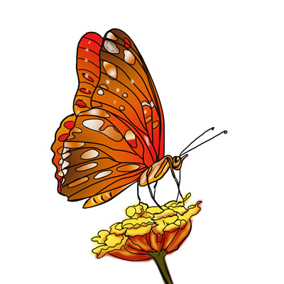

Welcome Back!
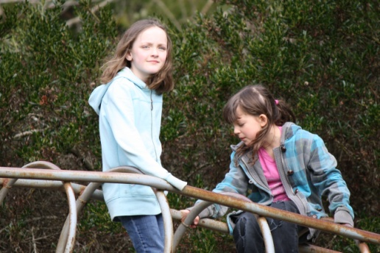
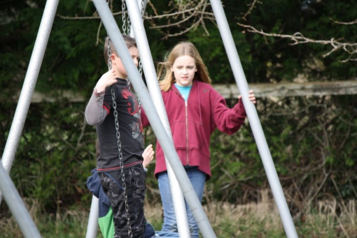
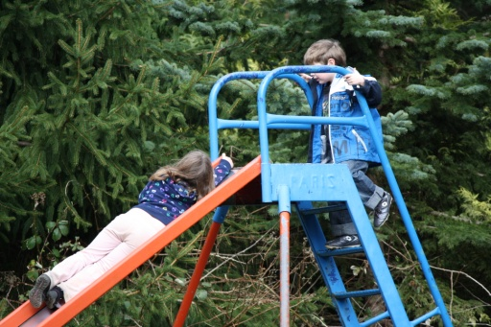

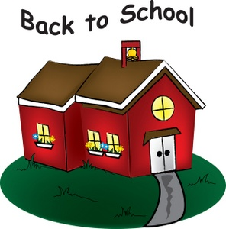
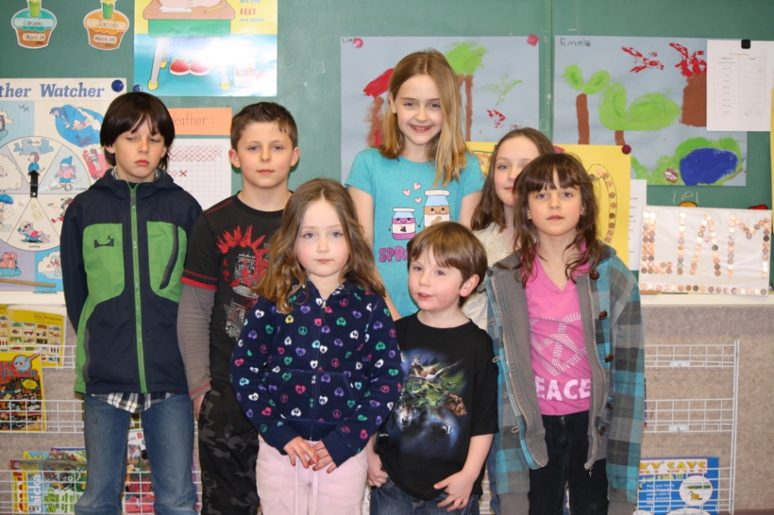
Volunteer Coast Guard Visit
The VCG will be giving our kids a lesson on Boat Safety from 10:45am to 12:00pm on Tuesday April 5th.
Upcoming Events

Wednesday April 6th. - PAC Meeting
Wednesday April 13th. - School Board Meeting

We have guests this week.
Welcome Hannah, Kaitlin and Emily.



